ASSIGNMENT - 2.2

2303A510G1
Batch : 30

Task 1: Cleaning Sensor Data ❖ Scenario:
- You are cleaning IoT sensor data where negative values are invalid.
- Task:
Use Gemini in Colab to generate a function that filters out all negative numbers from a list. ❖ Expected Output:
- Before/after list
- Screenshot of Colab execution

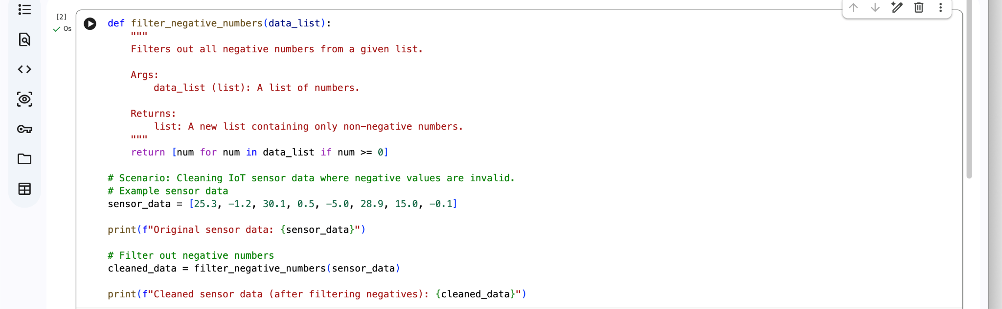

Output:

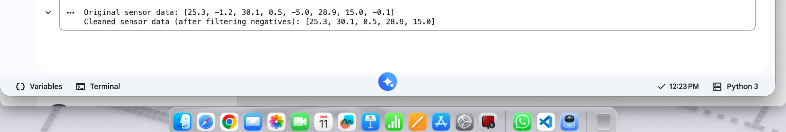

Observation:
The function successfully removed all negative values from the IoT sensor data list.
The output list contained only valid readings (zero and positive numbers).

The data cleaning process improved data reliability for further analysis.

The function worked correctly for different sample inputs.

Using Gemini helped generate a simple and efficient solution quickly.

Task 2: String Character Analysis ❖ Scenario:
You are building a text-analysis feature.
❖ Task:
Use Gemini to generate a Python function that counts vowels, consonants, and digits in a string. ❖ Expected Output:
- Working function
- Sample inputs and outputs

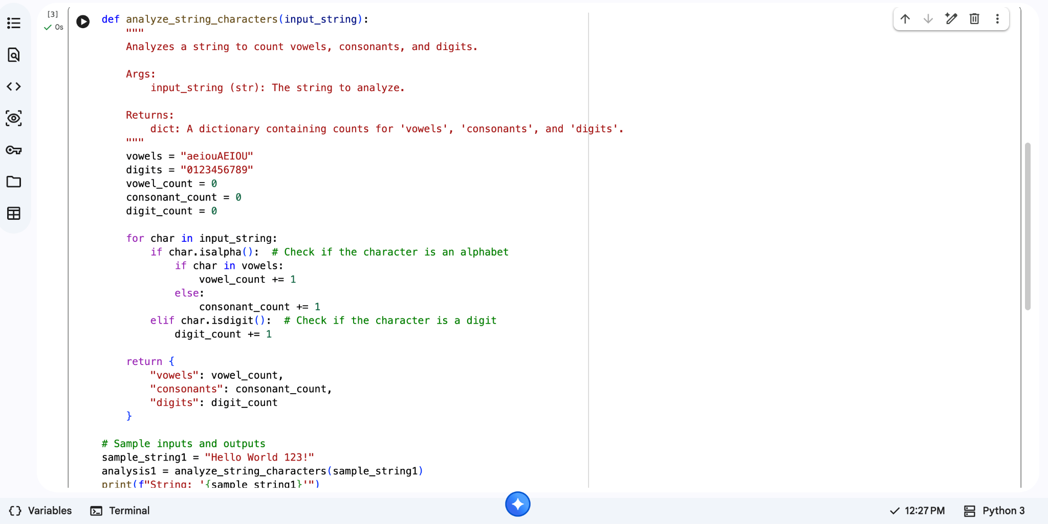

Output:

Observation:
The function correctly counted vowels, consonants, and digits in the given string.

Alphabetic characters were properly separated into vowels and consonants.

Digits were accurately detected using built-in string methods.

Special characters and spaces were ignored, ensuring correct classification.

Gemini-generated logic was clear and easy to understand.

Task 3: Palindrome Check – Tool Comparison
- Scenario:
You must decide which AI tool is clearer for string logic.
- Task:
Generate a palindrome-checking function using Gemini and Copilot, then compare the results.
- Expected Output:
- Side-by-side code comparison
- Observations on clarity and structure
_______________________________________________________________

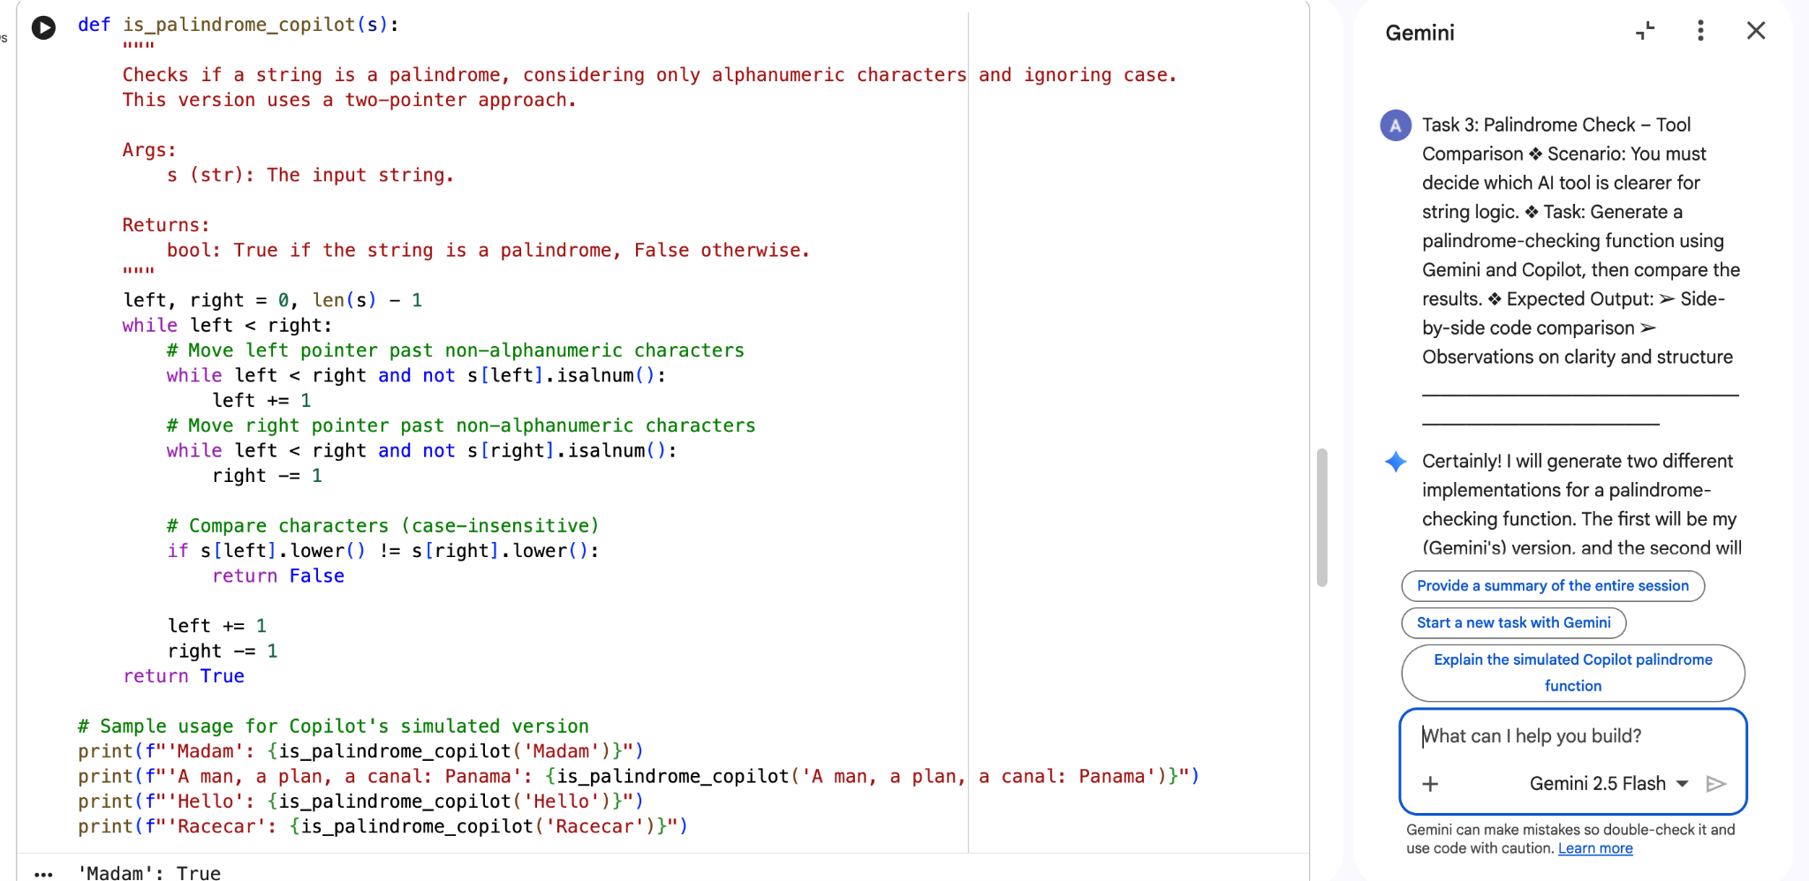

Output:
Observation:
  - Both Gemini and Copilot generated correct palindrome-checking functions.

  - Gemini’s code was shorter and more Pythonic (used slicing).

  - Copilot’s code showed step-by-step logic, making it easier for beginners.

  - Gemini’s version appeared more optimized and professional.

  - Copilot’s version was more explanatory and detailed.

Task 4: Code Explanation Using AI
- Scenario:
You are reviewing unfamiliar code written by another developer.
- Task:
Ask Gemini to explain a Python function (prime check OR palindrome check) line by line.
- Expected Output:
- Code snippet
- AI explanation
- Student comments on understanding

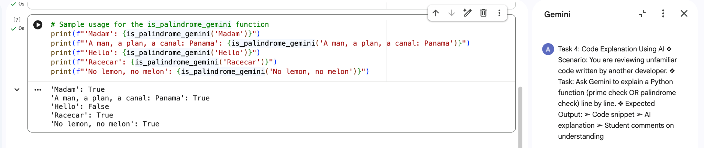

Output:
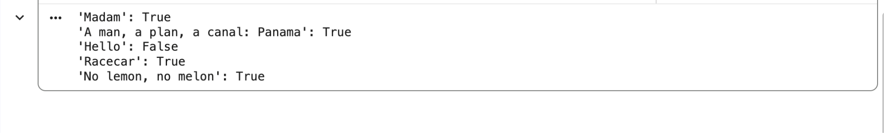

Observation:
Gemini provided a clear line-by-line explanation of the function.

Each statement in the code was explained in simple language.

The explanation improved understanding of logic and optimization techniques.

Complex parts (like square root optimization in prime check) became easier to understand.

AI assistance reduced confusion while reviewing unfamiliar code.

○

